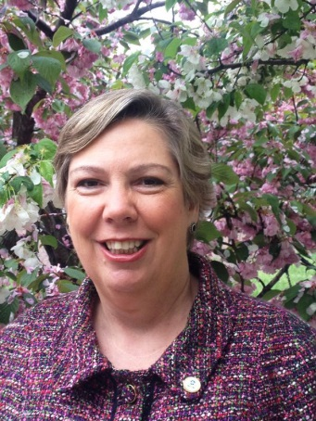
Judith Enck
Environmental Policy Expert
Judith founded Beyond Plastics in 2019 to end plastic pollution through education, advocacy, and institutional change.
Passionate about protecting public health and the environment, she teaches classes on plastic pollution as a Senior Fellow and visiting faculty member at Bennington College, and was recently a Visiting Scholar at the Elisabeth Haub School of Law at Pace University.
Judith has held top influential positions in state and federal government. Appointed by President Obama, she served as the Regional Administrator of the U.S. Environmental Protection Agency, overseeing environmental protections in NY, NJ, eight Indian Nations, Puerto Rico and the U.S. Virgin Islands – in addition to managing a staff of 800 and a $700M budget.
Previously, Judith served as Deputy Secretary for the Environment in the New York Governor’s Office, and Policy Advisor to the New York State Attorney General. She was Senior Environmental Associate with the New York Public Interest Research Group, served as Executive Director for Environmental Advocates of New York and the Non-Profit Resource Center, and is a past President of Hudson River Sloop Clearwater.
Judith appears on a weekly public affairs radio show on a local NPR affiliate, the Roundtable on WAMC in Albany, NY.
Judith lives in upstate New York with her husband, where they built their passive solar home with their own hands and with lots of support from friends and family. She designed her town’s rural recycling program. She is a proud parent and enjoys reading and following the news in her spare time.

